|  |
| --- |
| End Of Project Report |
| Cylinders & Orders Management System (COMS) Project |
|  |

**This page has been intentionally left blank**

|  |  |  |  |
| --- | --- | --- | --- |
| Filing Reference : |  | | |
| Document Title: | End Of Project Report | | |
| Version : | 1.0 | | |
| Prepared by : | Tran Ba Tien | | |
| Date Created : | Saturday, December 31st, 2011 | | |
|  |  | |  |
| Approved by : | ___________________ | |  |
|  | Alvin Chang | | Date |
|  | Quality Manager | |  |
| **© 2011 Hoang Kim Joint Stock Company.**  **The information contained in this document is the property of Hoang Kim Joint Stock Company. The contents must not be reproduced, wholly or in part, for purposes other than for which it has been supplied, without the prior permission of Hoang Kim Joint Stock Company, or, if it has been furnished under contract to another party, as expressly authorised under that contract. Hoang Kim Joint Stock Company shall not be liable for any errors or omissions.** | |  | |

**Document Reference:**

|  |  |  |  |  |
| --- | --- | --- | --- | --- |
| **Version** | **Date** | **Author** | **Remarks** | **Authorised by** |
| 1.0 | 31/12/2011 | Tran Ba Tien | Created Document | Alvin Chang |
|  |  |  |  |  |
|  |  |  |  |  |
|  |  |  |  |  |
|  |  |  |  |  |

**Cylinders & Orders Management System (COMS)  
 Project**

**End Of Project Report**

**Distribution:**

|  |  |  |
| --- | --- | --- |
| **Name** | **Department** | **Organisation** |
| Tran Ba Tien | SE18-Team2S | MTech (ISS) |
| Maung Tin Kyaw Oo | SE18-Team2S | MTech (ISS) |
| Chang Parkk Khiong Alvin | SE18-Team2S | MTech (ISS) |
| Koh Ming Jin | SE18-Team2S | MTech (ISS) |
| Junaith | SE18-Team2S | MTech (ISS) |
| Phyo Phyo Lwin | SE18-Team2S | MTech (ISS) |

**Table of Contents**

1 INTRODUCTION 1

1.1 Background 1

1.2 Team Members 1

1.3 Achievements 2

1.4 Key choices 2

2 TECHNICAL WORKS 2

2.1 Requirements Identification 2

2.2 Requirements Specifications 2

2.3 Design Modeling 3

2.4 Programming 3

2.5 System Integration Testing 4

3 EVALUATION 4

3.1 Project Outcome 4

3.2 Challenges faced 5

3.3 Conclusions and Future Work 5

# INTRODUCTION

This report is about the Cylinders and Orders Management System (COMS). It is built for Hoang Kim Joint Stock Company to manage their sales orders and production line. For the project requirements, refer to 1.1.

The project was written as a .NET web application running on a server, using SQL Server database. Users will access the application through Internet Explorer web browser to use most of the functions. A separate local application written in .NET will be installed on selected machines to perform diagram drawing functions. The application was designed to be flexible, easy to maintain and extend.

The project was completed on schedule and can fulfil all the requirements stated in the requirement specifications. It will be deployed at client side for operation and will be subject to future change requests from users.

The details are described in the following sections.

## Background

Hoang Kim Joint Stock Company is one of the leading providers of printing cylinders in Vietnam. They are currently using the latest technologies from Germany and Japan, and their client bases include various Vietnamese corporations as well as across Southeast Asia.

The company operates a manufacturing line, starting with a sales order received from a customer. The cylinders will then be created and go through the manufacturing process, finally delivered to the customer.

The company would like to have an integrated IT system that can:

* Manage the main manufacturing process, i.e. sales orders and cylinders.
* Benchmark employees’ performance to calculate bonuses.
* Give management reporting tools for daily operations.
* Be easy to maintain and to add new features in the future.

## Team Members

The team members participating in the projects are as follow:

|  |  |  |
| --- | --- | --- |
| **Name** | **School Year** | **Position** |
| Tran Ba Tien | SE18 – 2nd Year | Project Manager |
| Maung Tin Kyaw Oo | SE18 – 2nd Year | Technical Lead |
| Chang Parkk Khiong Alvin | SE18 – 2nd Year | Quality Manager |
| Koh Ming Jin | SE18 – 2nd Year | Team Member |
| Junaith | SE18 – 2nd Year | Team Member |
| Phyo Phyo Lwin | SE18 – 2nd Year | Team Member |

## Achievements

* The system has fulfilled all the requirements in the requirement specifications.
* The project team managed to deliver the necessary documents, to facilitate maintenance and enhancement.
* The system has been designed over the web to ease installation and provide more control of resources.

## Key choices

* The Model-View-Controller (MVC) framework has been adopted so it can be reused and enhanced in the future.
* .NET platform has been chosen because the client’s company has staffs with .NET experiences.
* .NET 4.0 Entity Framework has been chosen to simplify database model and access. There’s no need to write data access classes and data transfer objects. These objects are reverse-engineered from the database schema.
* MS SQL Server has been chosen because the user’s existing IT environment are Windows servers. Furthermore, MS SQL Server works well with .NET framework.

# TECHNICAL WORKS



## Requirements Identification

The following were accomplished:

* Describe activities and timeline for the whole project. Estimate workload and assign team members to activities. Produce Project Plan.
* Define change control management. Define file structure and references. Define policies and procedures to control the quality of the project implementation. Produce Quality Plan.
* Conduct requirements gathering by visiting customer site to understand their daily processes. Interviewed managements and users to understand different perspectives and try to align their needs. Produce User Requirement Specifications to document all user requirements.

## Requirements Specifications

The following works were done:

* From the Requirement Specs, translate into Use Case Model Survey. Requirements become use cases that describe a function of the system.
* Produce class diagram, describing the main classes and the class structure of the system.
* Produce use case realization reports to describe the workflow of each use case.

## Design Modeling

The following works were done:

* Produce a prototype to show to users and try to understand what users wanted in terms of interface, and how user would like the flow to be. Produce Prototype Study Report to document user response.
* Translate the use case realization reports to .NET platform. Boundary objects become ASP.NET pages, controller objects become C#.NET objects, entity objects are combined into .NET Entity Framework.
* Design database schema to capture all data and store efficiently. Decides to use .NET Entity Framework to ease development workload for data access layer. The framework can be auto-generated from the database schema, so changes to the database can be quickly reflected.
* The system structure is as described below:



## Programming

The following were accomplished:

* Code the system. Assign technical leads to create the framework, development environment and GUI, to make sure everyone is using the same thing, minimizing conflicts. After that, divide workload into use cases and assign among 3 team members with more experiences or understanding of the flow. The other 3 members are assigned to produce various documents like User Guide, System Test Plan.
* Thick client uses GDI+ graphic programming because it’s an independent library supported on all Windows platform and it allows us to do very low level graphic programming.
* Web client uses Microsoft Reports to generate reports which can be printed and exported to many kinds of documents, because user reports may need to be stored as soft copies in different formats.
* Integrate components written by team members into an integrated system, frequently using SVN. That way the code is gradually integrated and any conflicts can be detected and resolved early.

## System Integration Testing

The following works were done:

* The Quality Manager (Alvin Chang) is assigned to write System Test Plan to describe the testing process, to keep it more in line with the Quality Plan. From UCRR, derive all the test cases, to make sure all functions will be tested. Define a sample data set to reflect real-life data. Enforce screenshot capture for each test case as a form of evidence.
* Conduct System Test. Assign each test member (Alvin Chang, Roger Koh, Junaith) a set of test cases to work in parallel.

# EVALUATION



## Project Outcome

The following results were achieved:

* The system has fulfilled all the requirements in the requirement specs. In addition we have managed to deliver the system to the client on time and get accepted.
* Despite various challenges we encountered, for example our team size was reduced from 9 to 6, heavy work commitment, we still managed our time to complete this project.
* One weakness is we did not meet as regularly as we have planned due to work commitment.
* Our strength is that our members are willing to learn, cohesive team. One member has strong technical skill in .NET platform and is willing to share.
* Another weakness is we can get distracted by other tasks and neglect to complete our tasks.

## Challenges faced

The following challenges were faced:

* Language barrier made it more difficult for us to understand the user’s needs. Only one team member can speak Vietnamese, so it became a single point of contact.
* The client is overseas, so more efforts are required to fulfil activities that involve users like requirements gathering, prototype demo.
* Management challenges in allocating man power, planning and re-planning to keep project on schedule

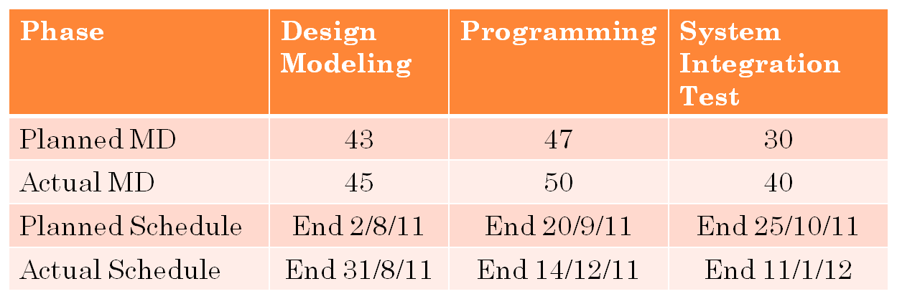

## Conclusions and Future Work

In conclusion, it is a good learning experience for the team, in terms of project, quality and control management and to have participated in a full end-to-end software project. Even though our scope was fairly huge but we have managed to complete the whole system and demonstrated to the client successfully.

Through this learning process, we have learned that planning should include more buffers to be able to handle manpower and schedule problems. In additions, defects detected in the early stage will help to avoid unnecessary delay and cost. Regular tracking is also important to keep project on schedule. Lastly, software designs should not just fulfill requirements but also target to cater for further enhance in terms of system flexibility, usability and maintainability (learnt from legacy systems at user side).

Future work for the system:

* Handle potential Change Requests from user. Use appropriate change request procedure to handle
* Conduct Data Migration activity. Perform data analysis migrated from existing system.
* Integration of Customer management function
* Monitor actual usage and study usability for future enhancements.